

|  |  |
| --- | --- |
| **Proposal By** | **Proposal To** |
|  |  |
| |  | | --- | | **Name:** | | **Name:** |
| **Designation:** | **Designation:** |
| |  | | --- | | **Telephone:** | | **Telephone:** |
| |  | | --- | | **Mobile:** | | **Mobile:** |
| |  | | --- | | **E-Mail:** | | **E-Mail:** |
| **Proposal Submitted on: 10-Jan-2024** | |

**PROPOSAL DETAILS**

|  |  |
| --- | --- |
| Confidentiality: | Confidential |
| Copyright and reproduction: |  |
| Validity: | 90 days |
| Reference Number: |  |

Proposal to:

NhP1 Plant

Project for:

Forecasting of Crimping Force in NhP1 Plant

Contents

1. Executive Summary 4

1.1 Company Profile: 4

2. Project details 5

2.1 Project Background 5

2.2 Project Objective 5

3. Project scope 6

3.1 Scope: 6

3.2 Out of Scope 6

3.3 Architecture 7

3.4 Pre-Requisites: 8

3.5 Assumptions: 8

3.6 Deliverables, Receivables and Acceptance Criteria 9

4. Project schedule 10

5. Risks & Mitigations 11

**GLOSSARY**

|  |  |  |  |
| --- | --- | --- | --- |
| **S.No** | **Module** | **Abbreviation** | **Full form** |
| 1 | Generic | BGSW | Bosch Global Software Technologies |
| 2 | Generic | CR | Change Request |
| 3 | Generic | MAPE | Mean Absolute Percentage Error |
| 4 | Generic | KPI | Key performance Indicator |
| 5 | Generic | SPOC | Single point of contact |
| 6 | Generic | OEM | Original Equipment Manufacturer |
| 7 | Generic | EDA | Exploratory Data Analysis |
| 8 | Generic | AI | Artificial Intelligence |

# Executive Summary

## Company Profile:

With over 25000 employees, BGSW is the largest software development center of Bosch outside Germany with presence in Europe, US, and Asia Pacific regions.

**Company Profile, Total revenue, and Number of Employees**

The Bosch Group is a leading global supplier of technology and services. In 2018, roughly 410000 associates generated sales of 78 billion Euros. Its operations are divided into four business sectors: Automotive Technology, Industrial Technology, Consumer Goods, and Energy and Building Technology.

The Bosch Group comprises of Robert Bosch GmbH and has more than 450 subsidiaries and regional companies across 60 countries. If sales and service partners are included, then Bosch is represented in roughly 150 countries. This worldwide development, manufacturing and sales network is the foundation for further growth.

BGSW is ISO 9001:2008 certified (2009), appraised at CMMI-L5 as per version 1.3 (2011) and ISO 27001 (2009) certified. We have state-of-the-art facilities in Bangalore and Coimbatore in India, Ho Chi Minh City in Vietnam, Guadalajara in Mexico, and Warsaw in Poland.

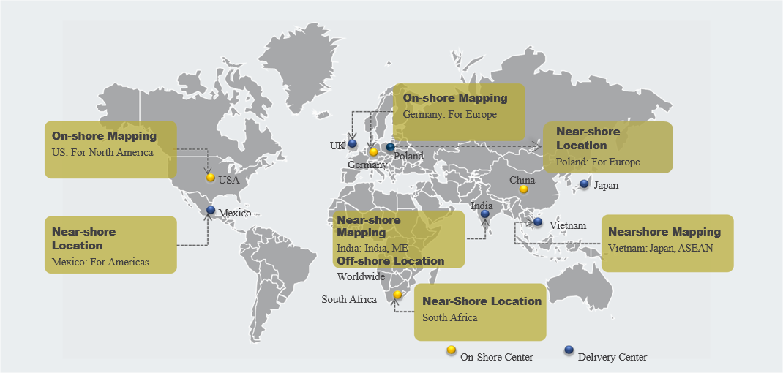

BGSW has established offshore, nearshore, and onsite locations to address the global need. BGSW therefore offers a balance between offshore economies of scale, and the proximity and cultural acceptance of Nearshore locations.

# Project details



## 2.1 Project Background

Crimping is a technique used to join two pieces of metal by deforming one or both to hold the other. In the context of the crimping process within DC-DC operations in a data center, crimping force analytics refers to the application of analytical methods and tools to assess and analyze the forces involved in the crimping of components. Crimping force is the force applied during the crimping process to create a secure and reliable connection between two components, typically involving the compression or deformation of materials.

The Primary objective of this POC is to build AI-Based Forecasting model for predicting crimping force in NhP1 plant. If forecasted force is out of tolerance limits, plant stakeholders can take necessary actions to prevent failure. Forecasting crimping force in a plant involves predicting the force required for the crimping process for the next seven days. This type of forecasting is crucial in manufacturing settings where precision in force application is essential for quality control and efficiency. Avoidance of failures minimizes the need for costly repairs, rework, or replacement of defective products. Decreased waste of materials and resources contributes to cost savings.

## 2.2 Project Objective

The primary objective is to predict crimping force for the next 7 days so that necessary actions can be triggered in case of predicted threshold breach.

# Project scope

## Scope:

Design and development of AI-Based Forecasting model for predicting crimping force in NhP1 plant. If forecasted force is out of tolerance limits, plant stakeholders can take necessary actions to prevent failure. Forecasting crimping force in a plant involves predicting the force required for the crimping process for the next seven days. This type of forecasting is crucial in manufacturing settings where precision in force application is essential for quality control and efficiency.

Detailed scope includes:

* Develop time series forecasting model using one-year (2022 – 2023) historical crimping force data including timestamps, and corresponding force values for a single line.
* Forecast quality validation against observed ground truth.
* Forecast will be generated at 5-minute level for next 7 days.
* Preparation of detailed PPT highlighting model performance and the approach taken along with comparison between the algorithm forecasted value and actual data for next 7 days.
* Forecasted results to be prepared in a csv file and shared once post model development.

**General:**

1. All documentations and business communication will be in English.

## Out of Scope:

1. Support co-ordination with OEM or 3rd party vendors for any product issues / bugs
2. Source system data availability and data quality related issues
3. Connection to any Database server for accessing data.
4. Setup and management of any DevOps / integration tools
5. No model deployment scope
6. Procurement and management of third-party licenses and certificates
7. Rollout to other locations
8. Any modifications / new developments to the existing source systems
9. Any Database administration activities
10. Any Module and functionality not described in the above scope section.
11. No additional features considered apart from parameters (crimping force) considered for forecasting.
12. Reporting
13. Mobile app / Report Development
14. Blueprint / Map visualization implementation
    1. Row Level Security feature
    2. UI/UX development
    3. Web App Development
    4. Administration activities
    5. SSO and AD integration

## Approach

Solution flow of forecasting model for predicting crimping force given below:

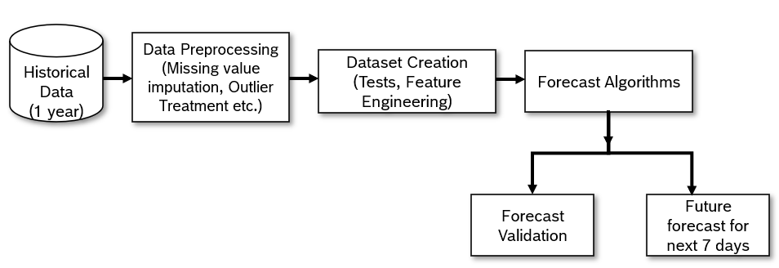

Detailed PPT will be shared post validation and the walkthrough of the approach will be provided to the customer with one-time virtual demo.

## Pre-Requisites:

Below are the key pre-requisites expected from NhP1 plant:

|  |  |  |
| --- | --- | --- |
| # | Project Phase | Pre-requisites |
| 1 | Project Kick Off | * Single point of contact (SPOC) from NhP1 plant. * Purchase order * Data availability from customer in csv format |
| 2 | Study | * 1 year (2022-2023) of historical crimping force data including timestamps, and corresponding force values will be shared by NhP1 plant as csv files. * Tolerance limit for crimping force to be provided. * NhP1 plant SPOC shall be made available for all technical queries and open point clarifications throughout the POC period. |
| 3 | Design & Development | * Business rules for any KPI calculations along with detailed source data mappings to be provided/ clarified by NhP1 plant. * 1 year (2022-2023) of historical crimping force data including timestamps, and corresponding force values will be shared by NhP1 plant as csv files. * Tolerance limits for crimping force to be provided. * Customer SPOC shall provide timely clarification of open points |
| 4 | Demo | * Availability of NhP1 plant stakeholders * NhP1 plant will share the actual crimping force data for forecasted period in appropriate prediction frequency for validation. * Report detailing out model performance on validation data. * Forecast report to be generated and shared in csv format. * Metric for evaluation will be MAPE. * One-time virtual demo will be provided to the NhP1 stakeholders to provide walkthrough of the solution. |

## Assumptions:

1. Scope creep will follow the CR process.
2. This is not a production grade deployment.
3. Any product / feature limitations pertaining to OEM shall be routed to OEM for support.
4. In case of scope creep, revised estimates for schedule and costs will be mutually discussed and agreed.
5. Data quality is good enough to generate proper forecast.
6. The target parameter (crimping force) is not affected by any other unaccounted factors, in such scenarios target forecast accuracy may not be achieved.
7. Customer is responsible for Data Ownership and Data Quality
8. Post data quality assessment acceptance criteria to be revisited.
9. Appropriate prediction frequency will be remodified post discussion and analysis of first set of results.

## Deliverables, Receivables and Acceptance Criteria

|  |  |  |  |  |
| --- | --- | --- | --- | --- |
| # | Project Phase | Deliverables by BGSW | Receivables from NhP1 plant | Acceptance Criteria |
| 1 | Project Kick Off | * Project plan and schedule with milestones * Team structure | * Purchase Order * Project Level Agreement * Project Team Structure | * Deliverables are in line with the project scope. |
| 2 | Study | * Initial findings on data quality | * Data schema * Clarifications on need basis * Data in csv file format (one-year 2022 – 2023 historical data, tolerance limits) | * Solutioning covers identified requirements. |
| 3 | Design & Development | * PPT on EDA * Initial forecast results of model | * Clarifications on need basis * Data in csv file format (one-year 2022 – 2023 historical data, tolerance limits) | * Solutioning covers identified requirements. |
| 4 | Demo | * PPT with approach to the solution, model performance and comparison between the algorithm forecasted value and actual data. | * Clarifications on need basis * Actual data for the forecasted period in appropriate prediction frequency in csv file | * MAPE between observed value and predicted forecast on the validation data is less than ~15 % |
| 5 | Closure | * PPT with approach to the solution, model performance and comparison between the algorithm forecasted value and actual data. | * Handover confirmation * Signoff on project closure | * No critical defects * No deviation from agreed scope |

# Project schedule

The indicative timeline for this POC is 2 months:

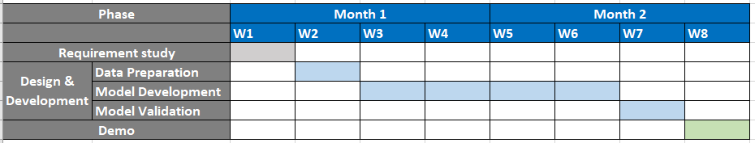

# Risks & Mitigations

|  |  |
| --- | --- |
| Risks | Mitigation |
| Unavailability of necessary Infrastructure/Source Systems or the interfaces for extraction of necessary data from the source systems | NhP1 plant team to ensure availability of all necessary infrastructure/Source Systems with necessary interfaces for data extraction as defined in the pre-requisites |
| Missing clarity of Data field mapping and Calculation for KPIs | NhP1 plant team to ensure availability of all Data field mapping and calculations documented and made available to BGSW team before the Design phase |
| Delay in acceptance of deliverables resulting in schedule and effort deviations | NhP1 plant should adhere to the plan for review and sign-off. |
| Disturbance due to Natural calamities and social chaos | NhP1 plant to have necessary Business Continuity Plan. Schedule to be revisited, adjusted and mutually agreed |